**EWQ Account _Bug report**

URl: https: <http://admin-qa2.eees.fi/>

User Name: kalam@gmail.comPassword:

# Sign in:

First time login also user sign in to the page, user received an error message in in the top of the application.

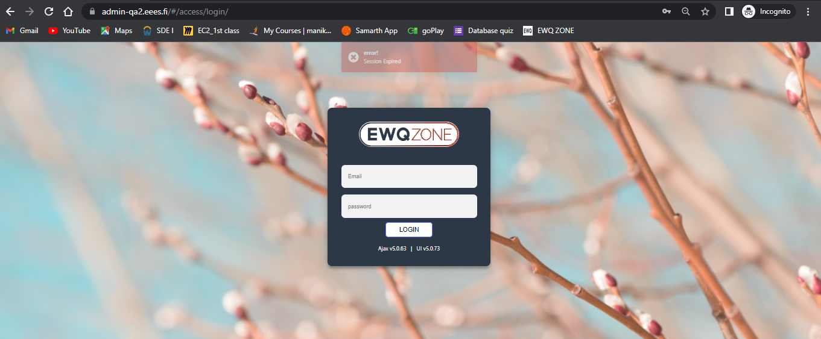

# Logout:

**Suggestion**: User Able to logout from Application without any pop-up or Intimation

Ex:

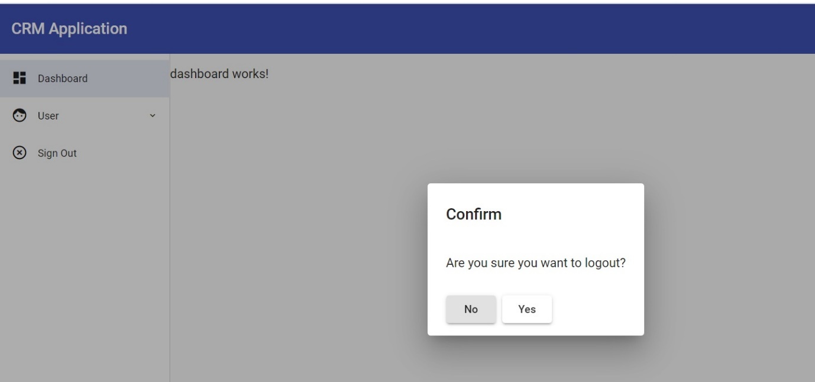

# Account Page:

1. This symbol shown in UI have no functionality, pls remove if it’s not required
2. Search bar/Go and “+” have extra height can we align all three boxes in same

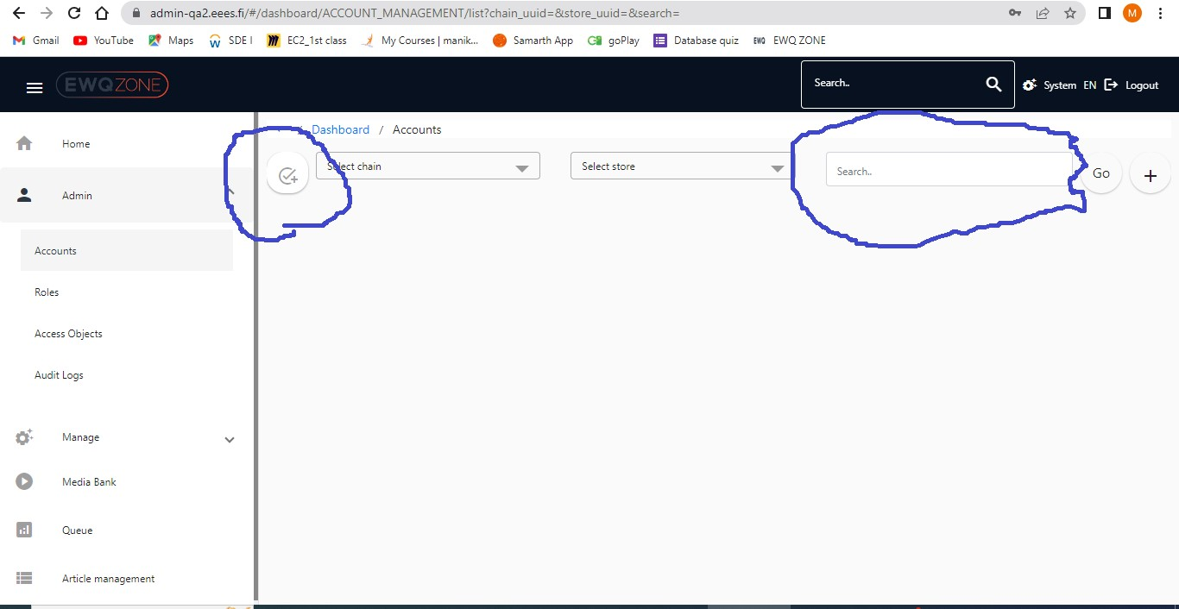

Scroll bar is Missing while user trying to Add Account in Account page:

User Unable to see Entire page (add account page) if user Zoom in.

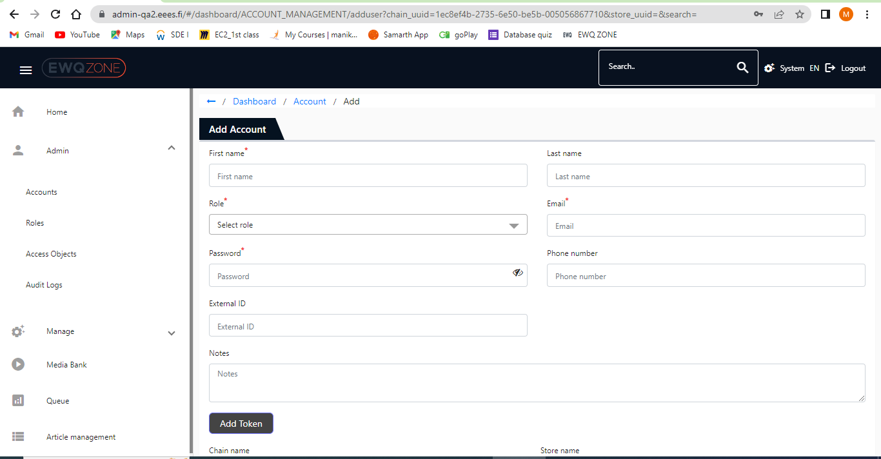

## Account Page _Pagination:

User Facing issue in pagination if he trying to Change count in Item per page:

Page is Unresponsive/Lagging is very high/ Sometimes Page is in frozen as well.

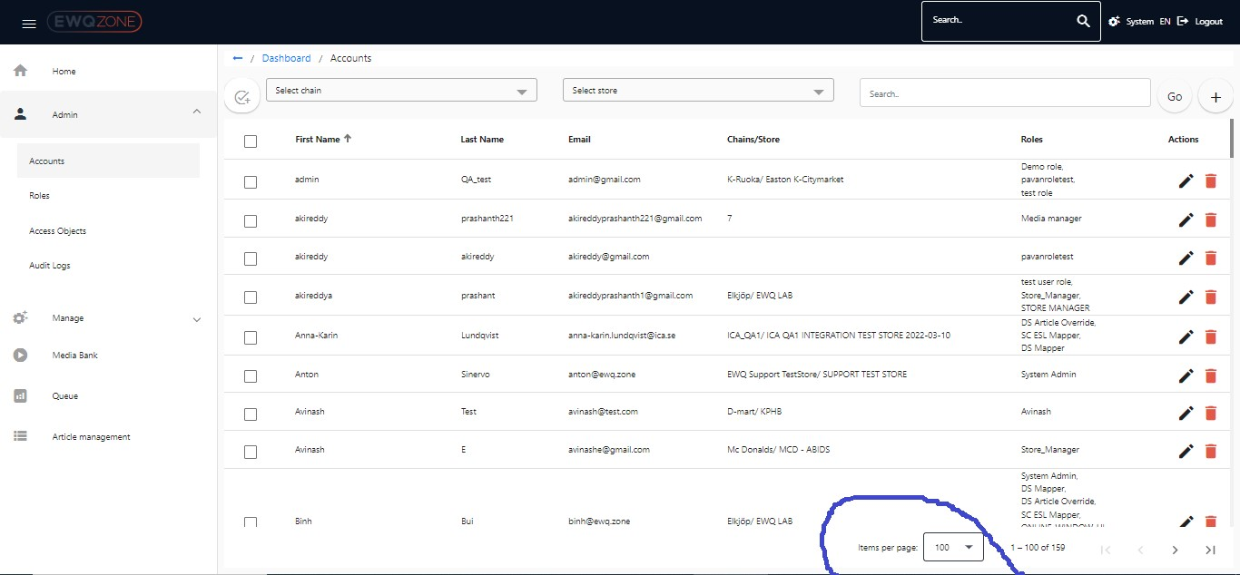

If Click on Edit account option received a distorted UI in Headers bar

If User click on Name Directory in edit account page, user needs to navigate User Account page, but the option is Not working in edit page option.

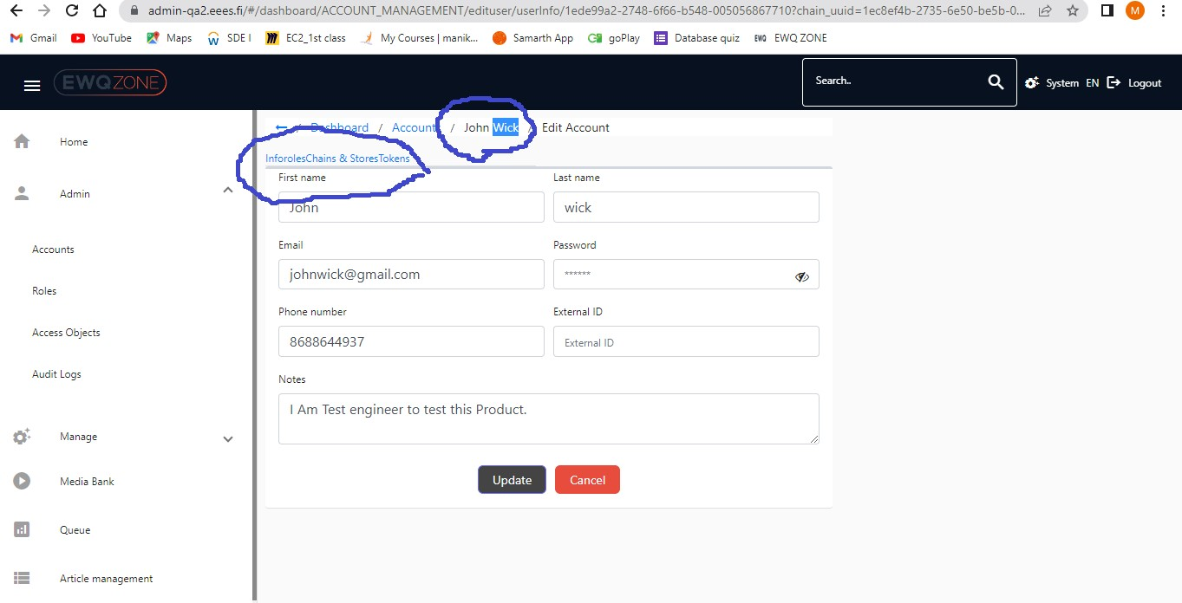

**Misplacement of Action Buttons:**

When User Place mouse over on Edit action Button/click on Edit action button, user Navigated to Delete action page.

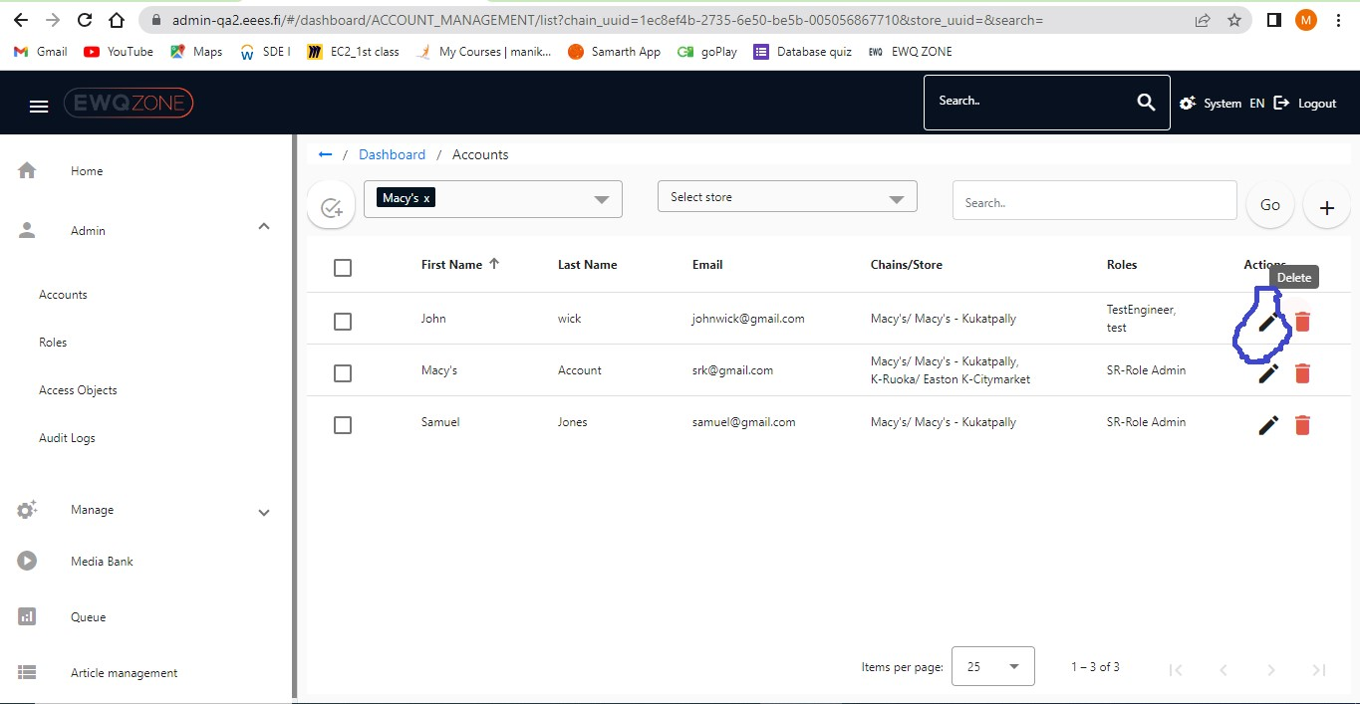

# Roles:

The Functionality of “+” button and Add Roles has same.

Remove any one of the option due to the functional behaviour is same.

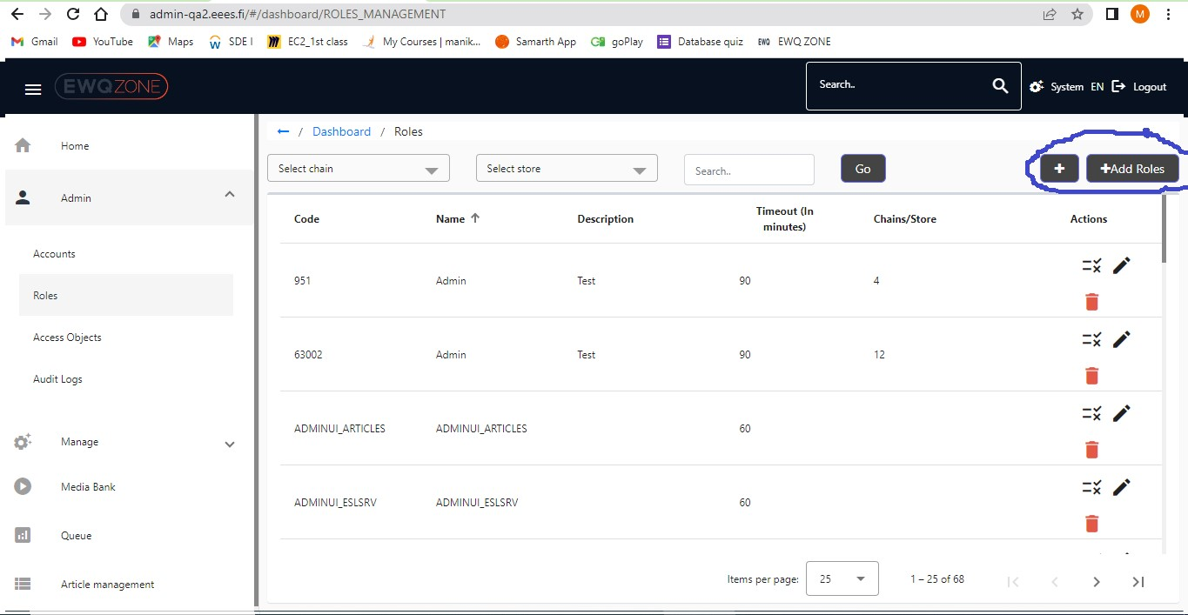

In Privileges screen All elements should be in same alignment:

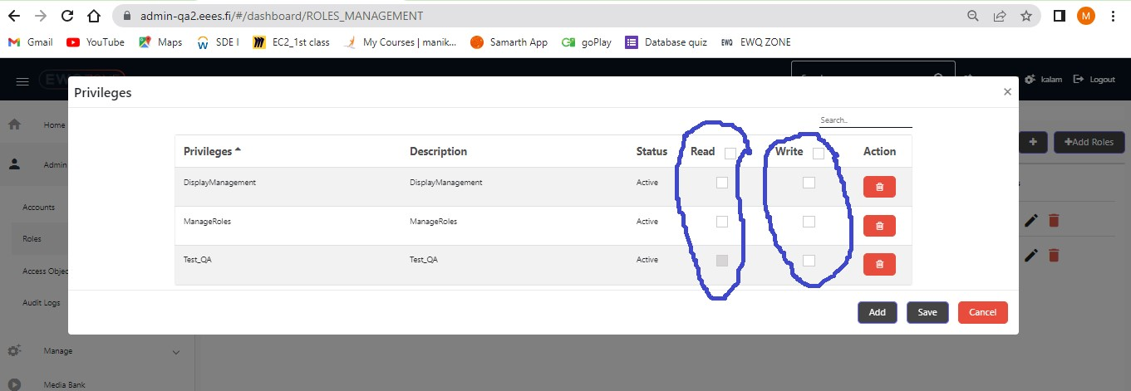

## Roles pagination:

User Facing issue in pagination if he trying to Change count in Item per page:

Page is Unresponsive/Lagging is very high/ Sometimes Page is in frozen as well.

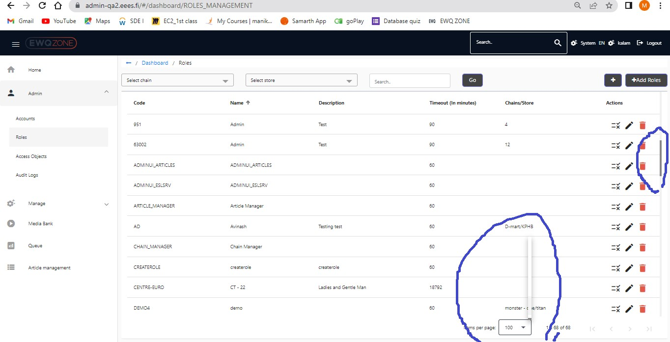

# Access Objects:

In Access object Page Alignment of Search Functionality and other option should be in proper height.

Alignment of Search function also should be in proper.

The Functionality of “+” button and Add Objects has same.

Remove any one of the option due to the functional behaviour is same.

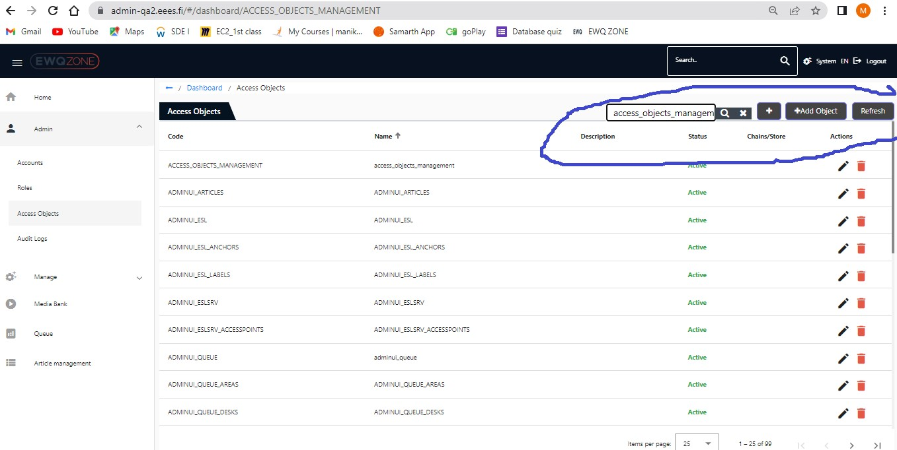

## Access objects pagination:

User Facing issue in pagination if he trying to Change count in Item per page:

Page is Unresponsive/Lagging is very high/ Sometimes Page is in frozen as well.

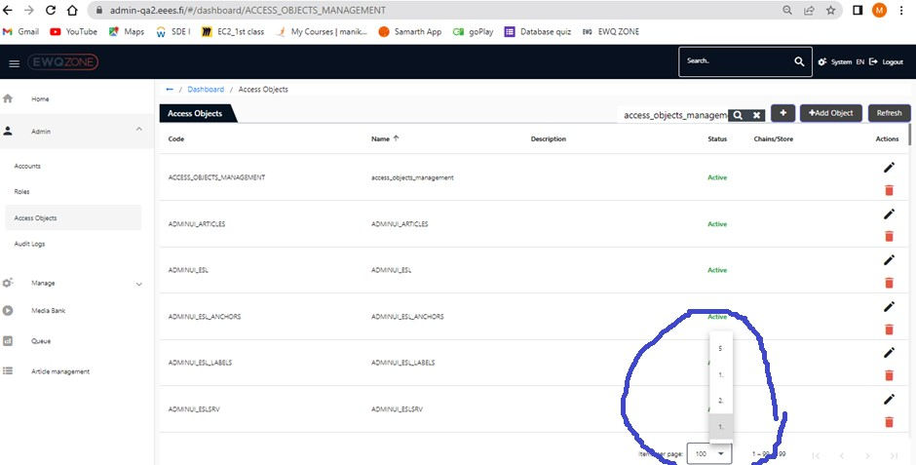

Refresh Button is Unresponsive/Not Working in Access objects page:

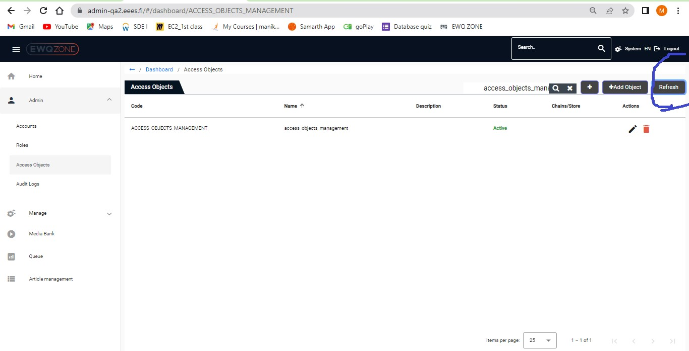

In Access object, if User Click on edit option User able to an un expected error message displayed in the page.

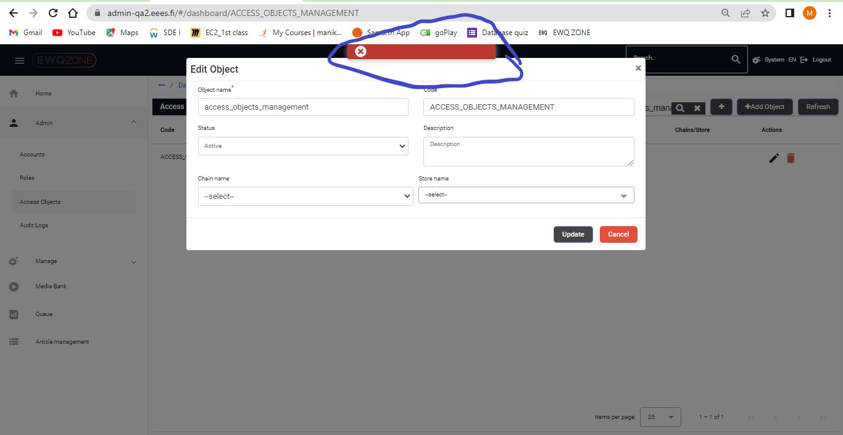

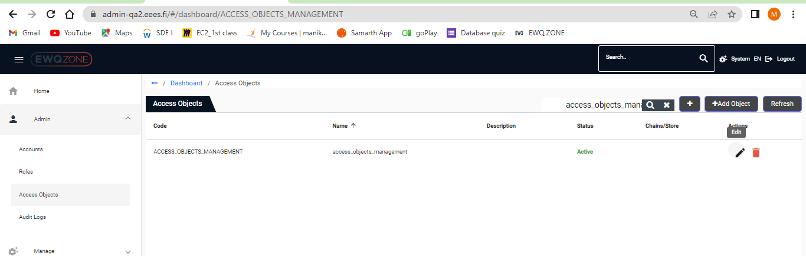

# Audit Logs:

In Audit Logs page, if user Click on any Account Uuid, user able to see distorted UI headers in the Page.

Page resolution issue should be fixed.

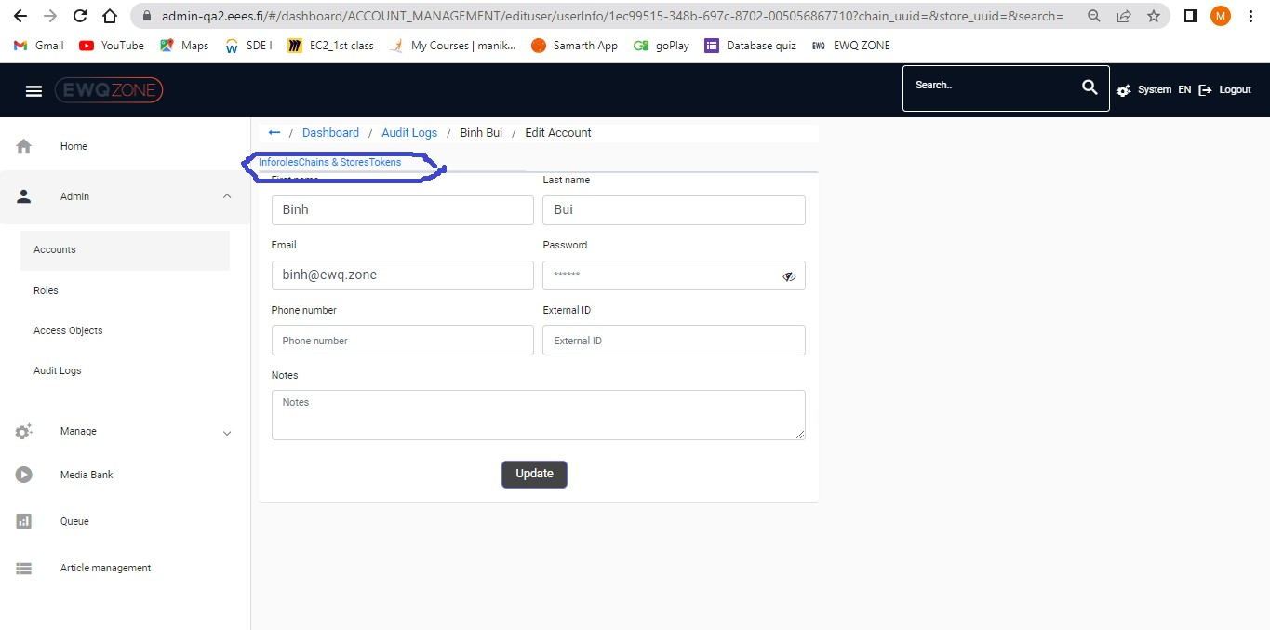

In Audit Logs Infor page if user Click on Password View option, user unable to View password

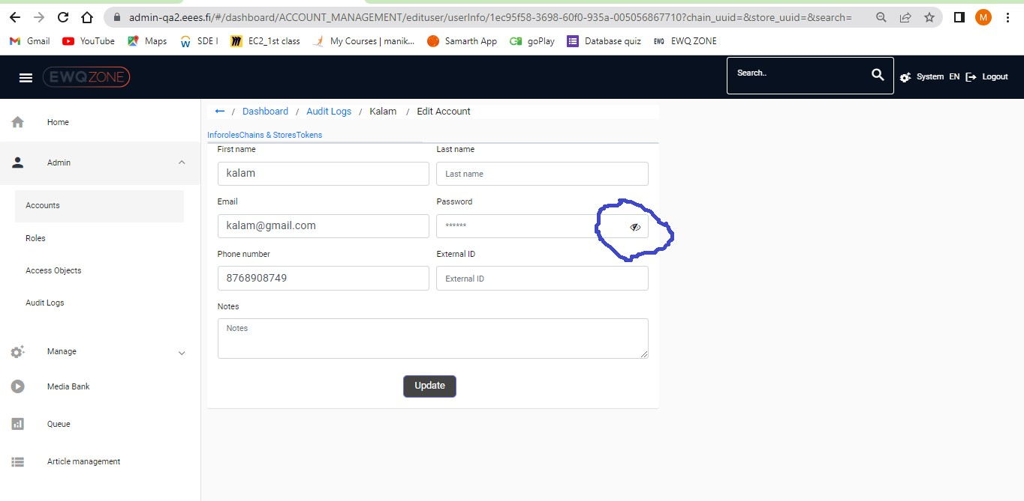

In Audit logs Chains & storage page resolution of Page Should be fix:

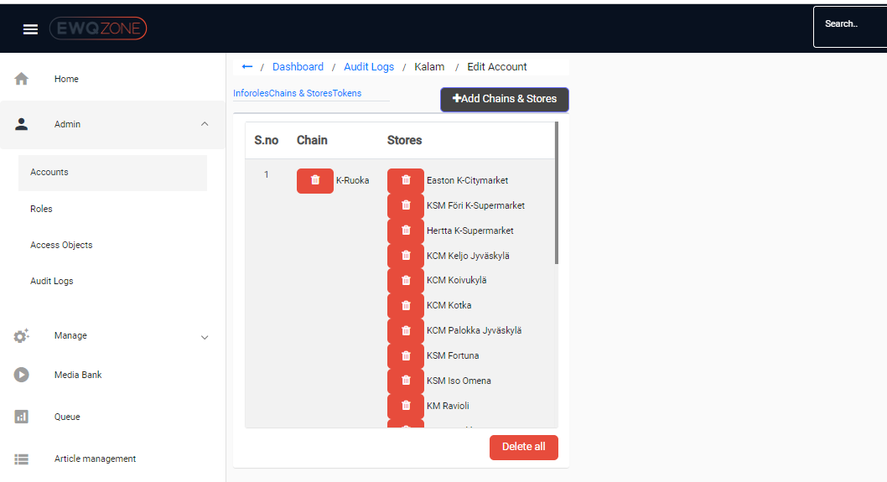

In Audit logs page edit Token option is nor working as expected.

Steps:

Click on Audit logs

Click on any Account Uuid

Click on Token

Click on Action-edit button

De activate Status

Click on Save

Check the Status again.

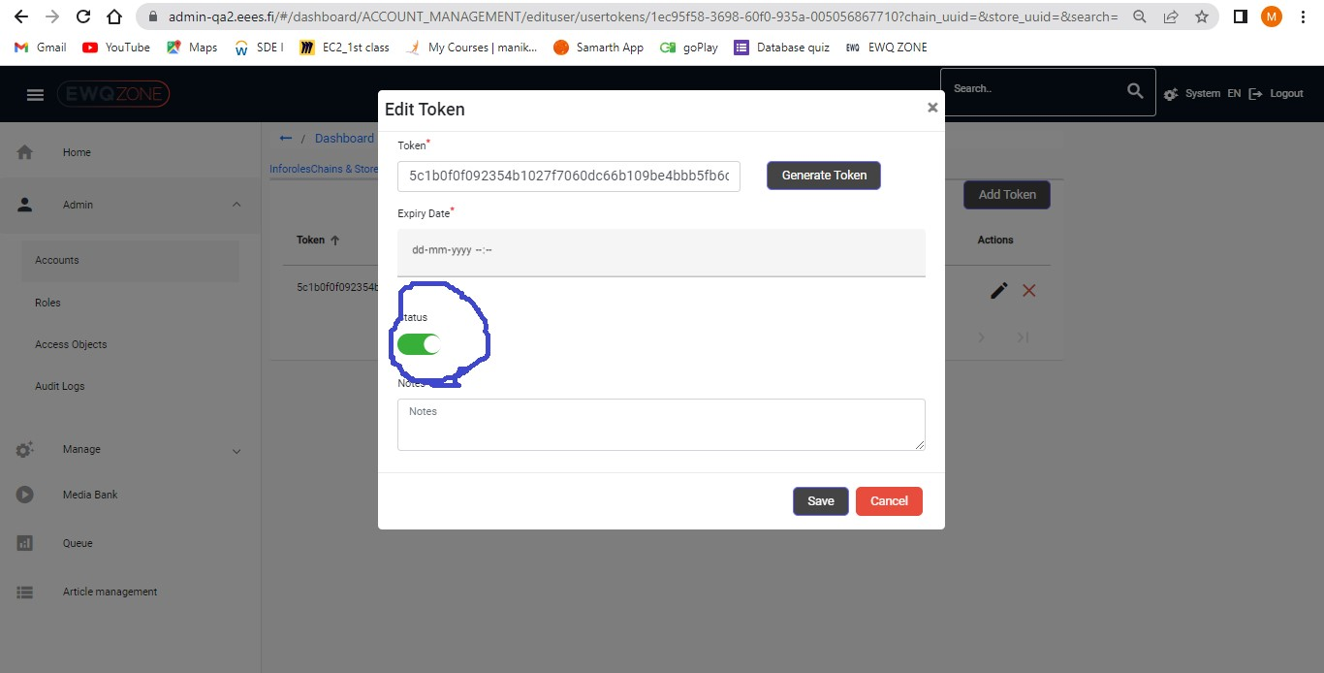

# Organizations:

Organizations spelling should be change

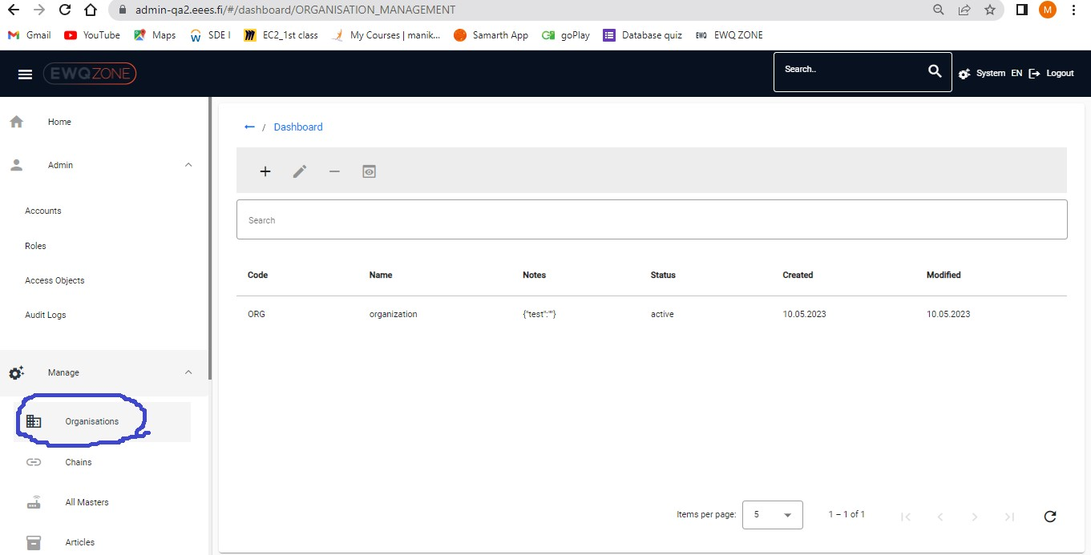

In Page headers are missing in Organization page:

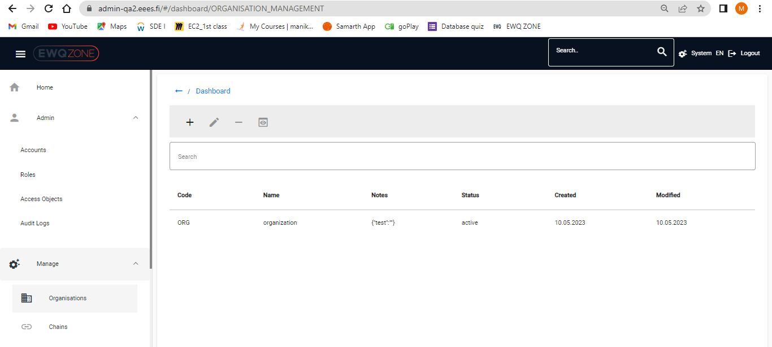

IF user click on back button/Dashboard in Organization page, user directly navigated to login page of the Application not to the back page

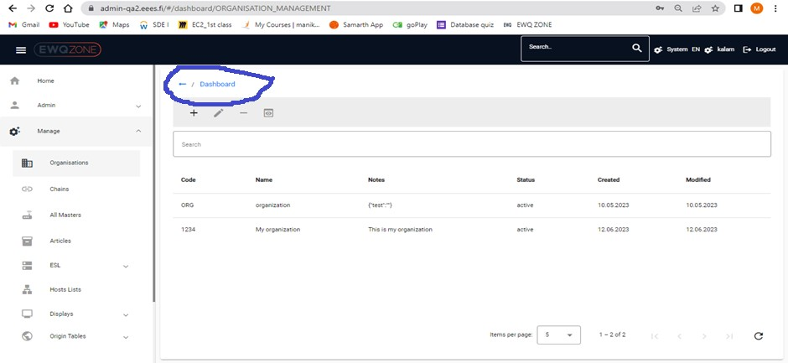

User directly Navigate to,

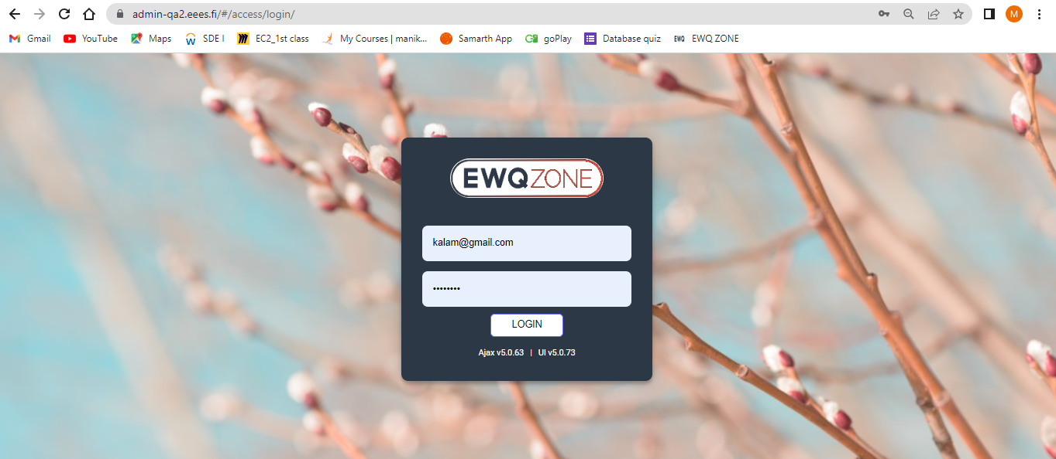

When User Selected any row in organizations page, it should be in highlight by dif colour and properly identified by user.

In the below Screen, user selected second row

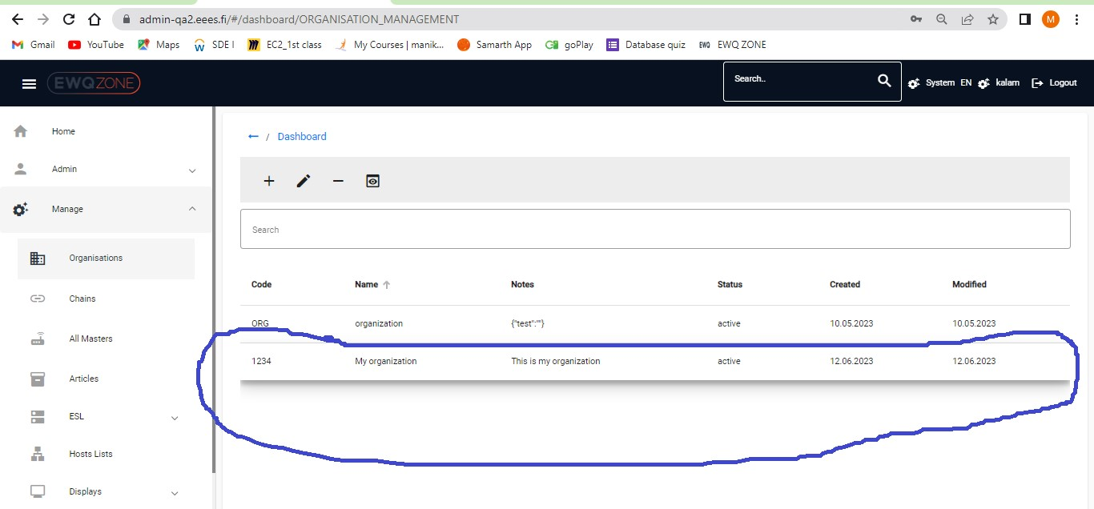

**Directory should be Dashboard/Organizations/info**

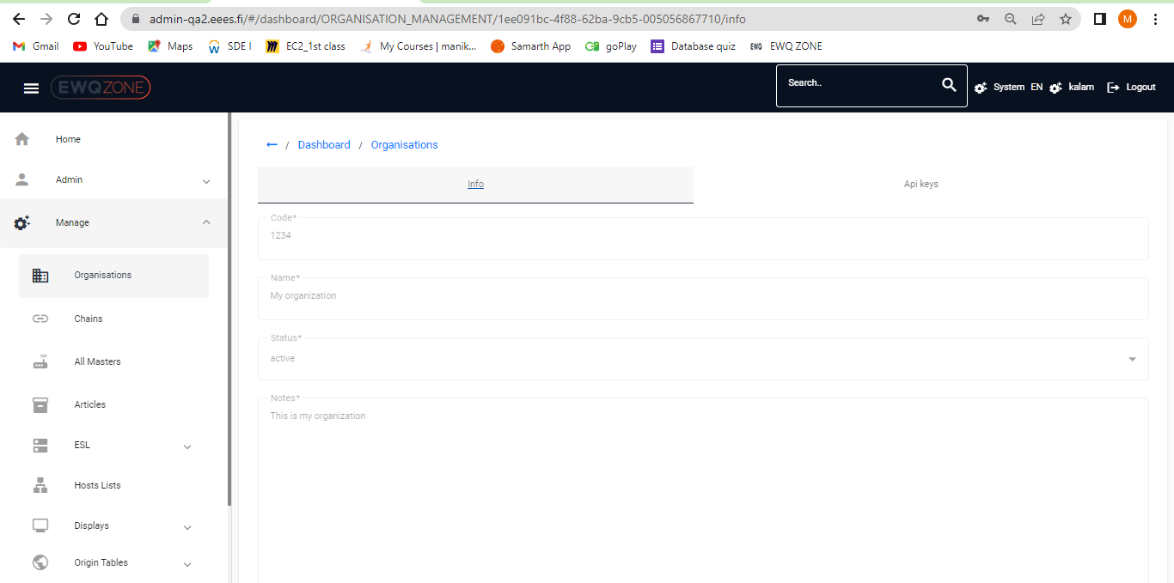

# Chains:

In Chains Page Alignment of Search Functionality and other option should be in proper height.

Alignment of Search function also should be in proper.

The Functionality of “+” button and Add Chains has same function.

Remove any one of the option due to the functional behaviour is same.

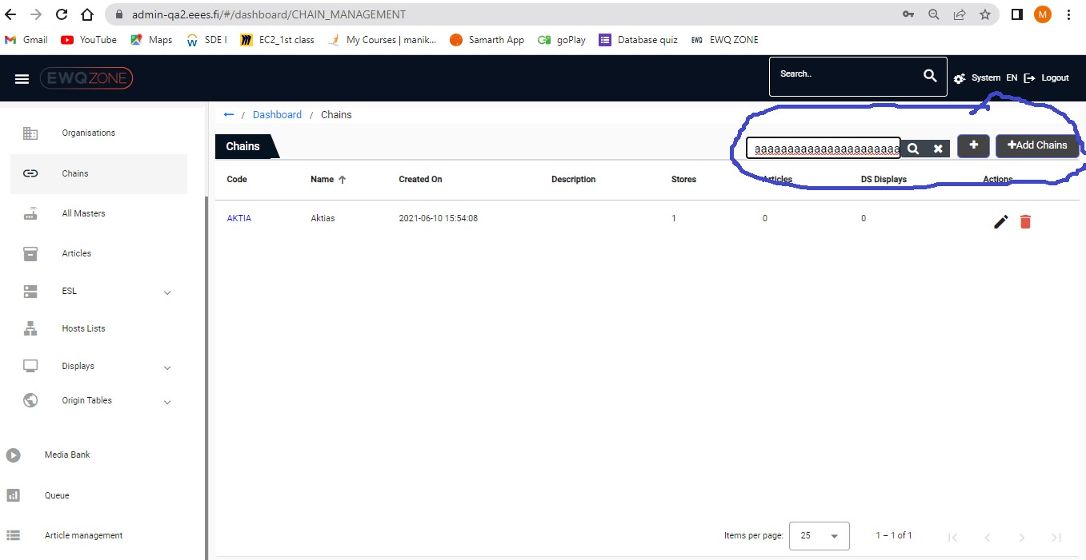

## Chains_pagination:

User Facing issue in pagination if he trying to Change count in Item per page:

Page is Unresponsive/Lagging is very high/ Sometimes Page is in frozen as well.

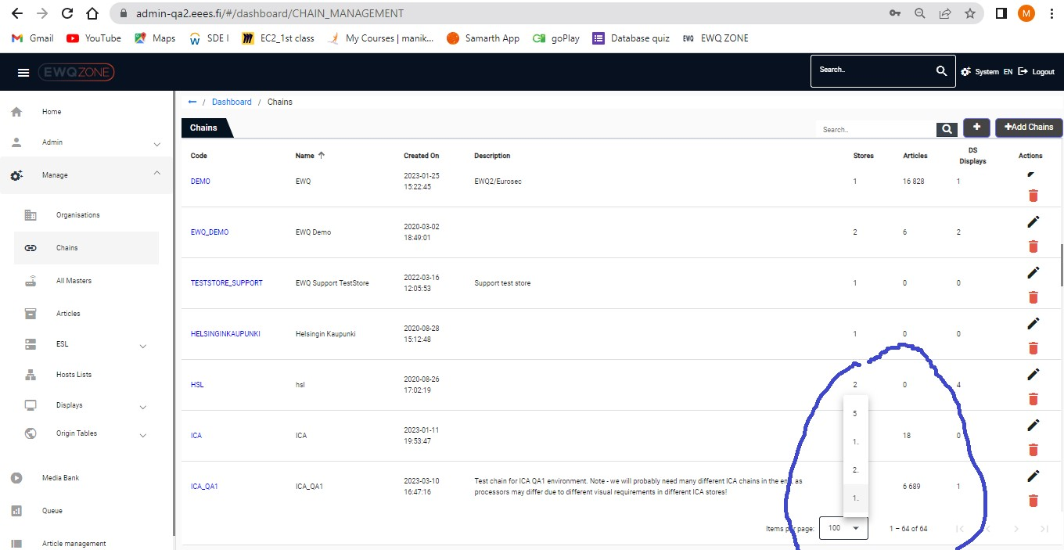

If user trying to open API keys in new tab, user able to Navigate to Info page.

Steps:

Click on chains

Click on any Code

Click on Api keys and try to open in New tab

Check the Navigation Page in new tab

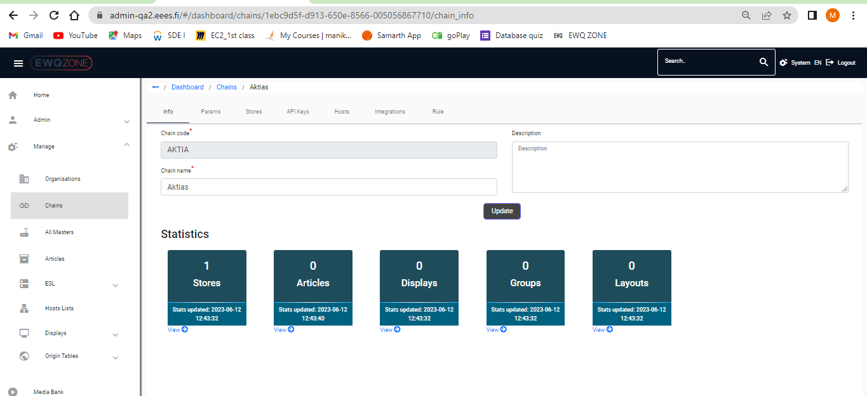

In Chain paras page We can Remove any one the “+” symbol or Add Chain Parameter due both have same in Functionality:

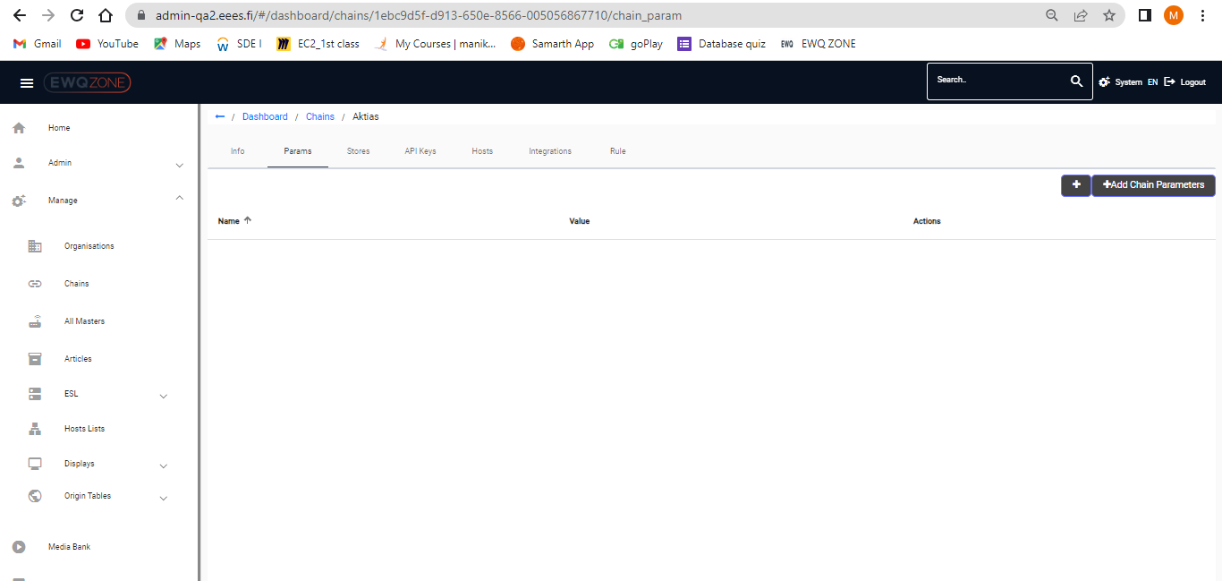

In Chain Param page, user unable to delete Chain parameters:

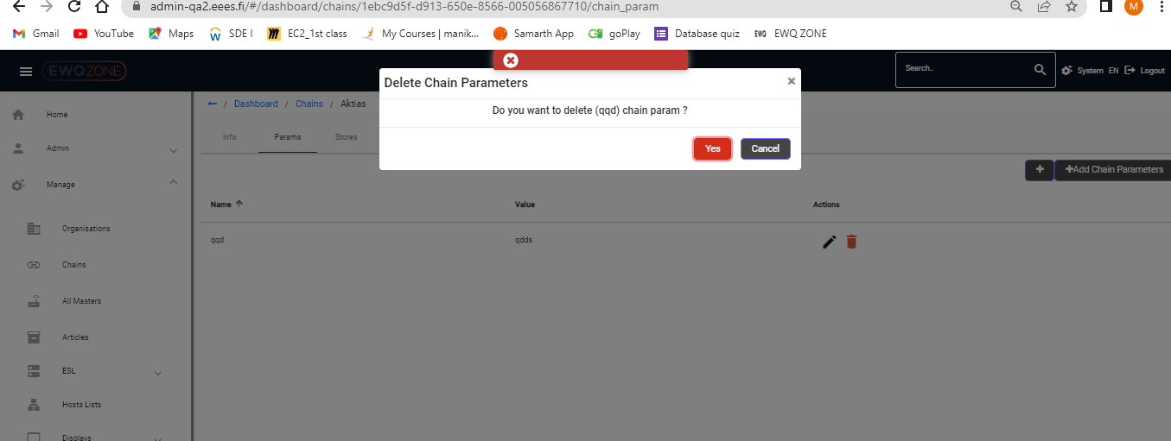

**In Chains param page:**

In Chains Page Alignment of Search Functionality and other option should be in proper height.

Alignment of Search function also should be in proper.

Directory also should be in proper:

The Functionality of “+” button and Add Chains has same function.

Remove any one of the option due to the functional behaviour is same.

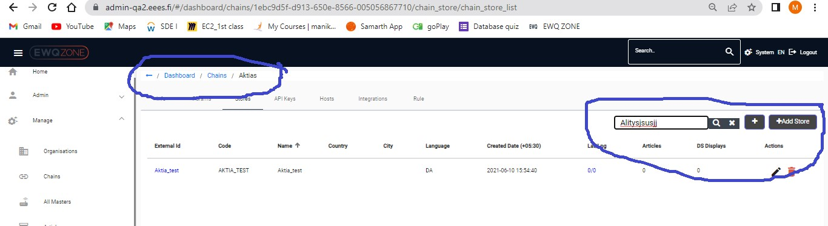

In Chains Store, user unable to update the page:

User received an un expected Error message while updating page.

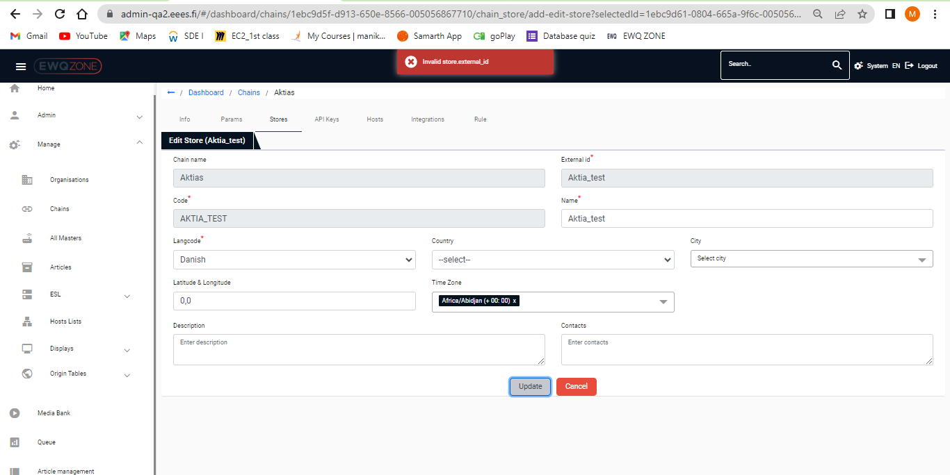

In Chains Store, User received an un expected Error message while updating page.

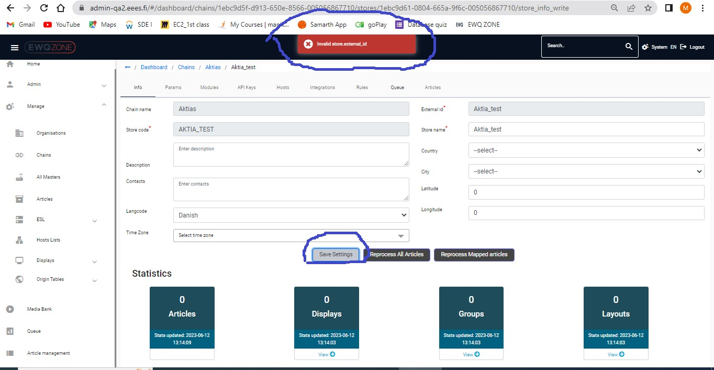

**In Chains Api-keys,**

The Functionality of “+” button and Add Chains has same function.

Remove any one of the option due to the functional behaviour is same.

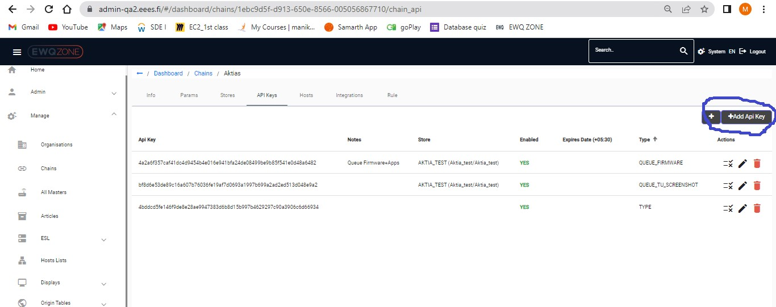

**Host:**

In Chains host Page Alignment of Search Functionality and other option should be in proper height.

Alignment of Search function also should be in proper.

Directory also should be in proper: **Dashboard/Chains/Aktias/Hosts**

The Functionality of “+” button and Add Chains has same function.

Remove any one of the option due to the functional behaviour is same.

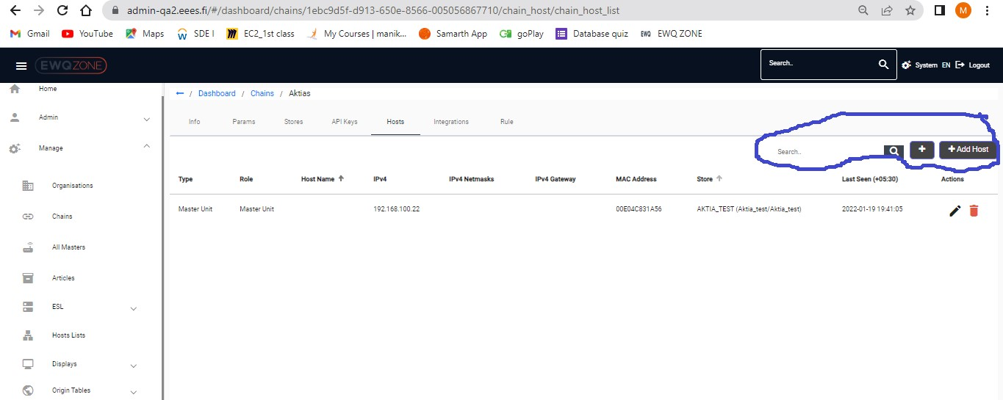

**Integrations:**

In Chains Integrations Page Alignment of Search Functionality and other option should be in proper height.

Alignment of Search function also should be in proper.

Directory also should be in proper: **Dashboard/Chains/Aktias/Integration**

The Functionality of “+” button and Add Chains has same function.

Remove any one of the option due to the functional behaviour is same.

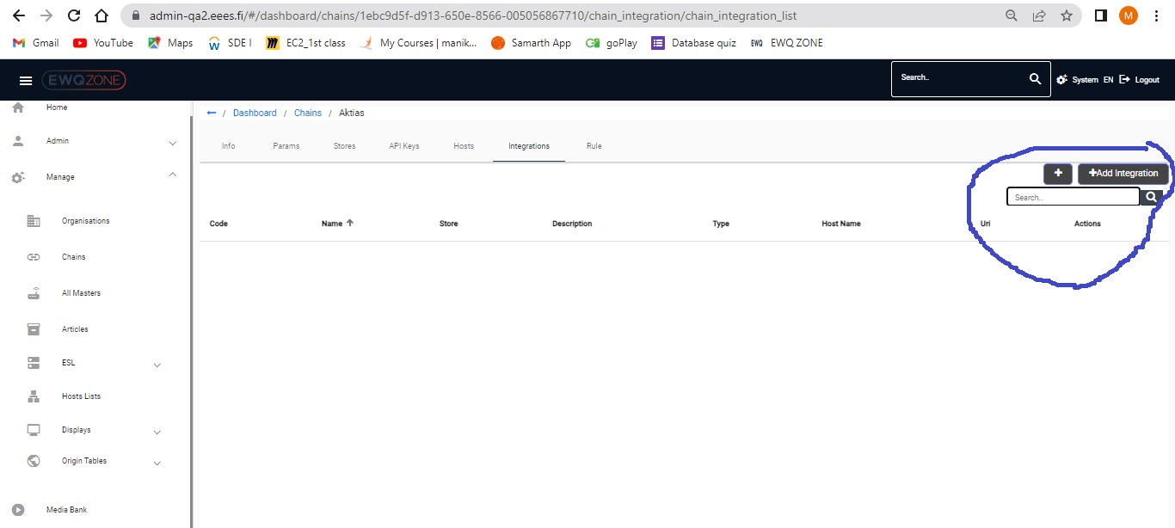

# All Masters:

User receives an Invalid error message when user click on any UUID in the page, and also page is loading continuously.

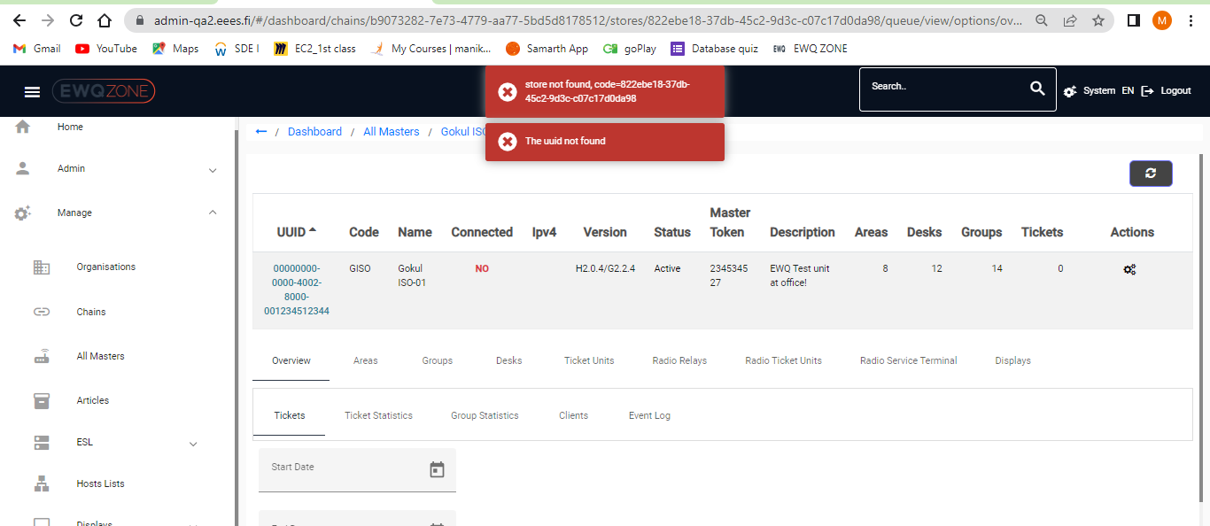

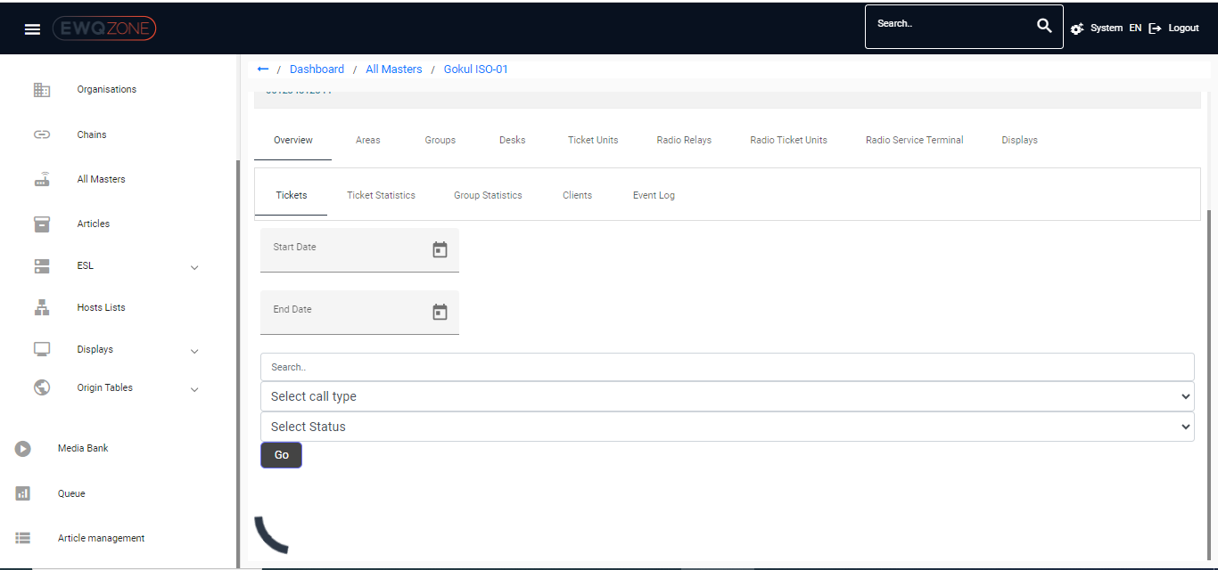

In All master’s page scroll bar is missing to scroll up/down



# Articles:

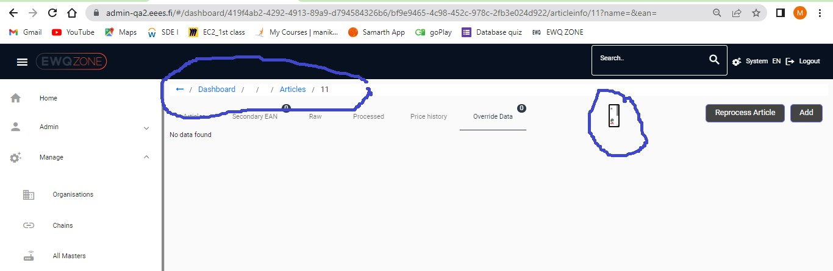

Scroll Bar Missing: User Not able to Scroll down/up

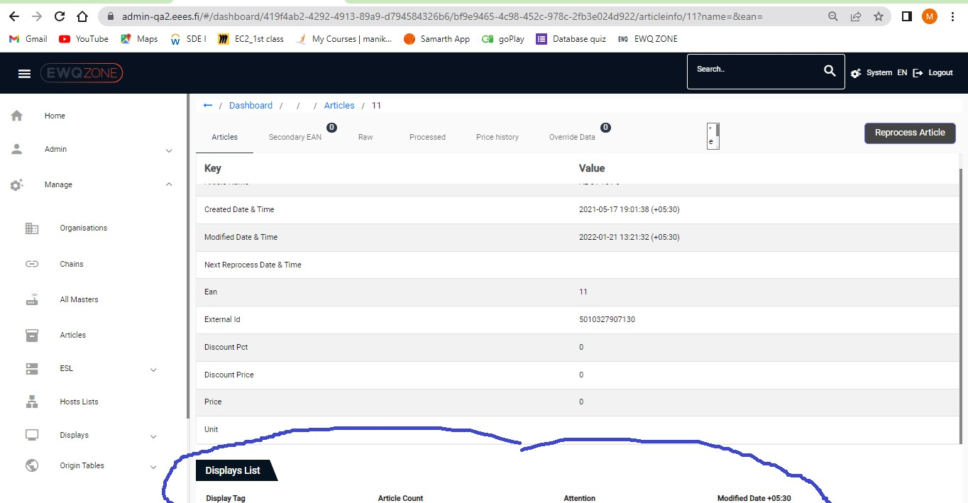

# ESL:

Directory should be change in ESL Server change:

Scroll Bar is Missing to Scroll up or down

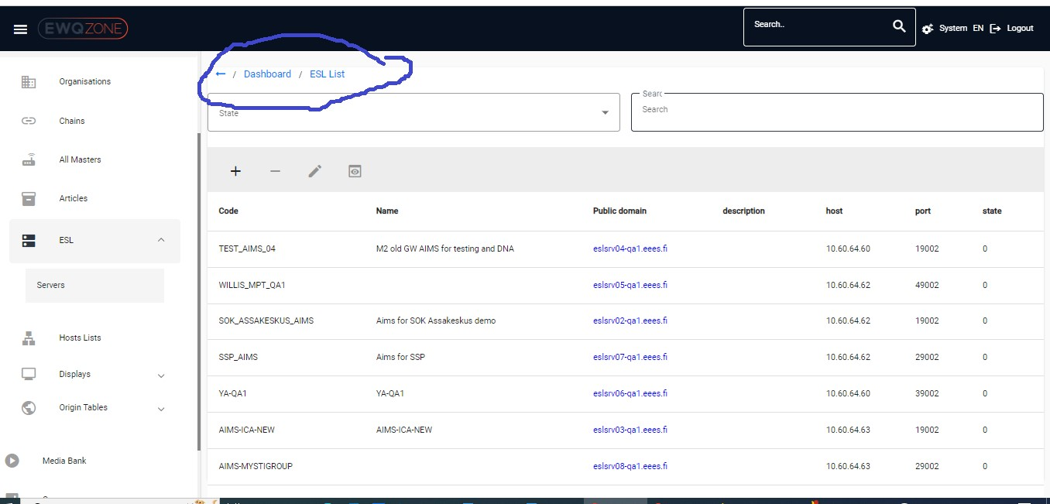

If user select any row in the option, the row should be highlight with dif colour.

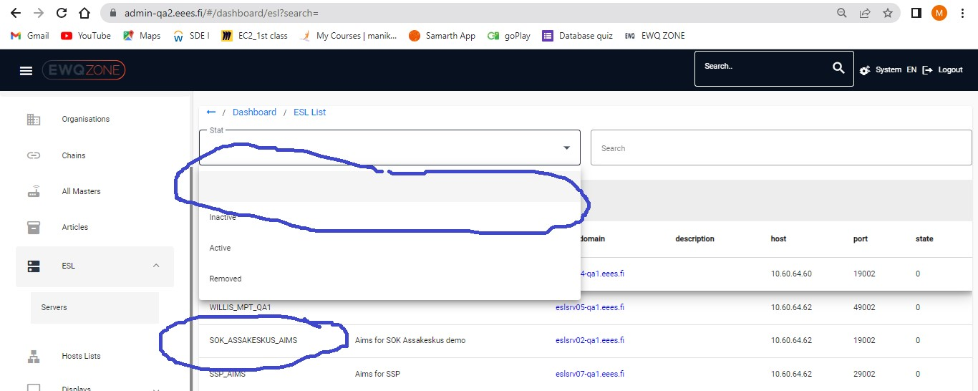

**Hosts Lists:**

Can we put pleader in the middle of the screen it is very odd when it is in left corner.

Scroll bar is missing to Scroll down/ up

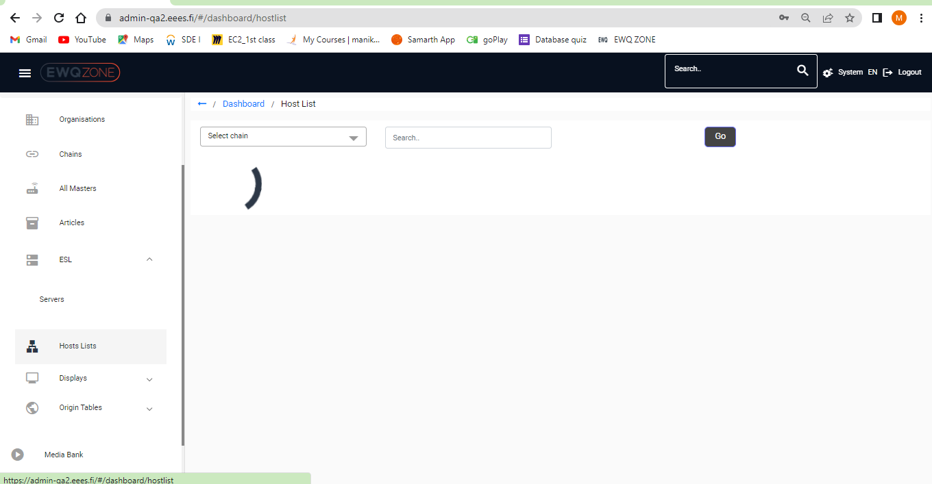

User Unable to open Hosts list in New tab/ not responding

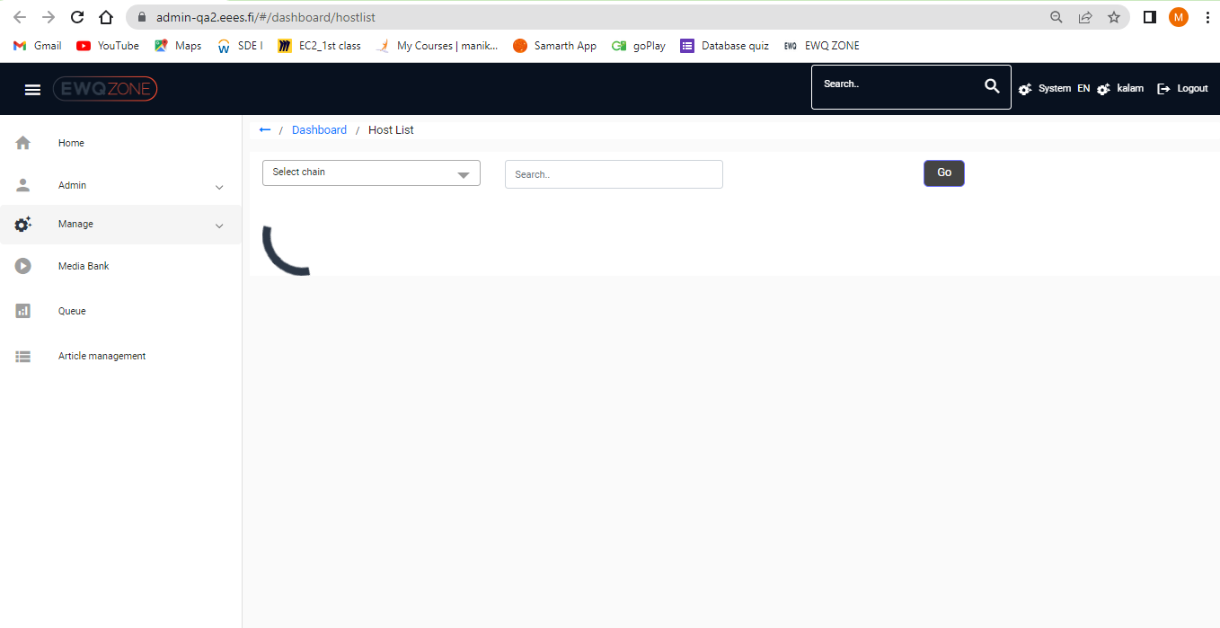

# Dispalys:

The Functionality of “+” button and Add Displays has same functional.

Remove any one of the option due to the functional behaviour is same.

Filter Boxes should be in proper alignment.

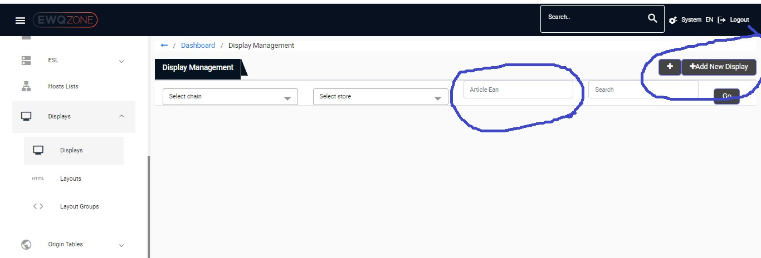

In filter section it should be good we have an option for selecting /de selecting all option.

Scroll bar is missing for scrolling top to down/UP.

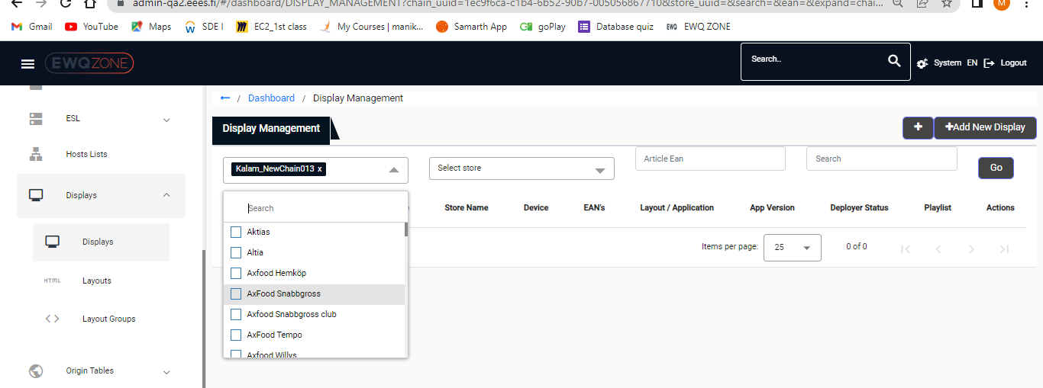

The un wanted Symbol existed when User selected specific Display, Un even icon placement.

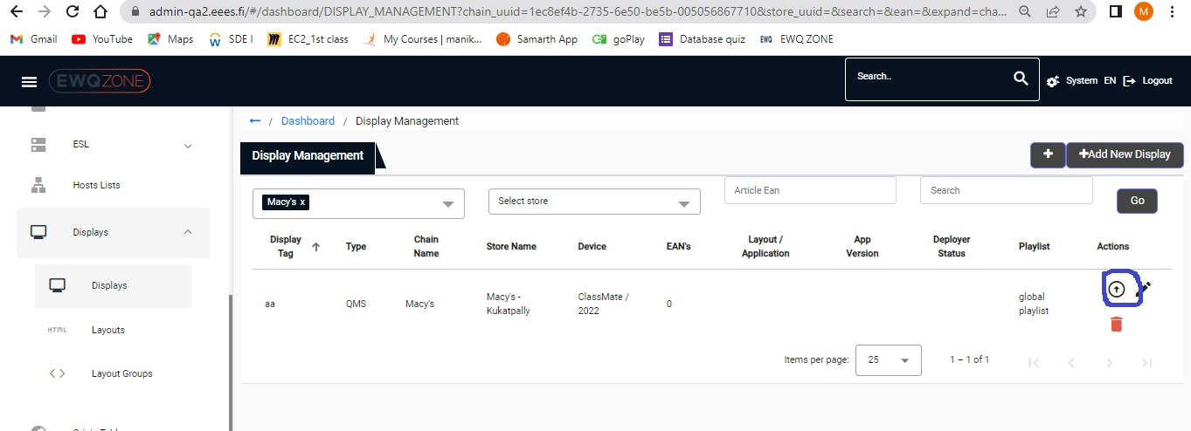

User able to see Distorted UI when user trying to Edit Display:

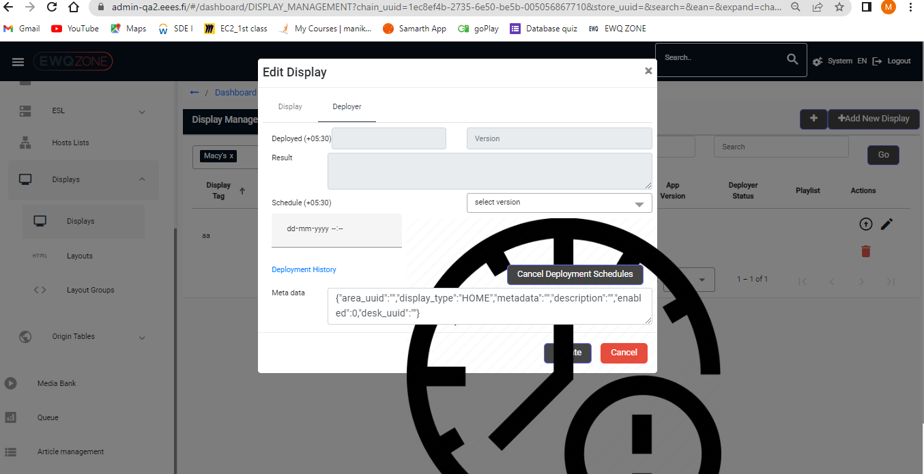

# Layout:

Scroll bar is missing in Layout Management.

We Need to check whether the header is Layout or Layout Management

Extra Symbol or Names displaying in Task bars

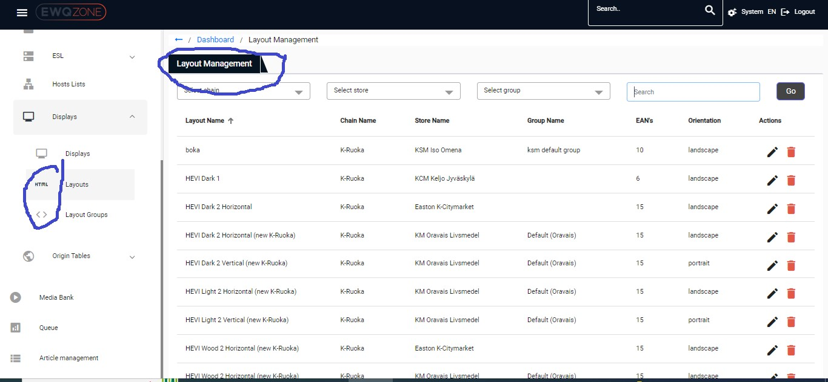

# Layout groups:

Both Search functional box and Symbol are should be in proper alignment.

Action Buttons are not Highlighted/Not working.

Scroll Bar Is missing for Scroll up/down

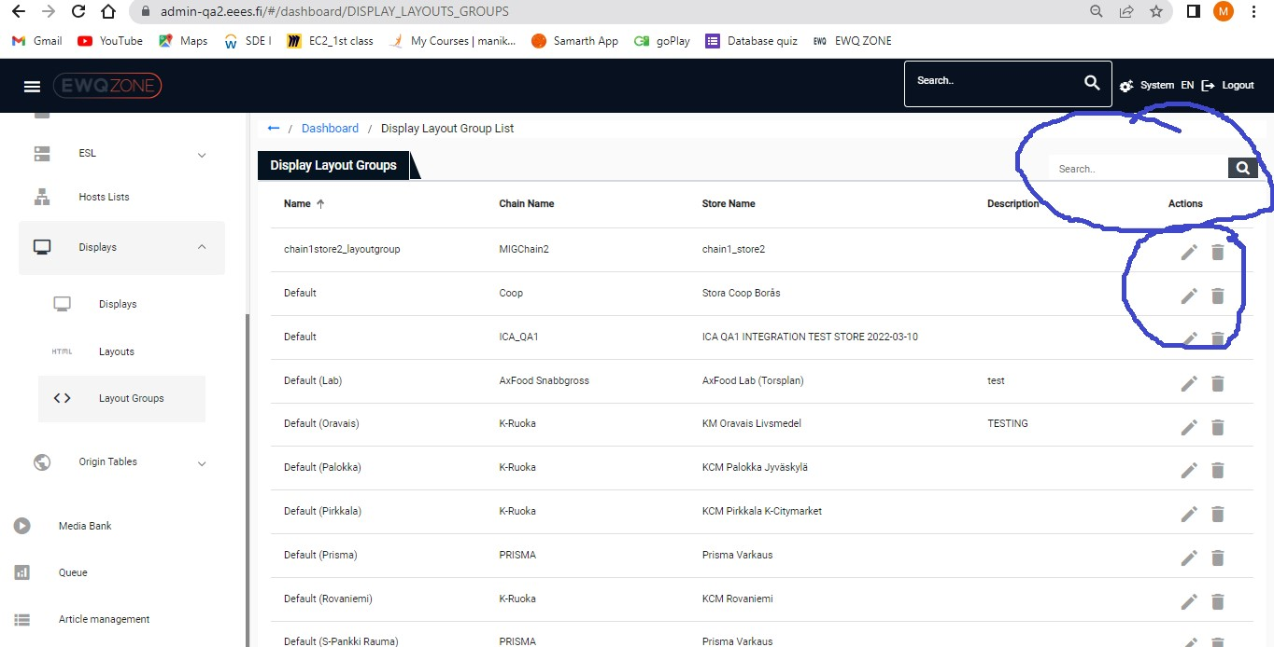

# System:

Wen User Click on System -overview user able to see distorted UI for Overview screen.

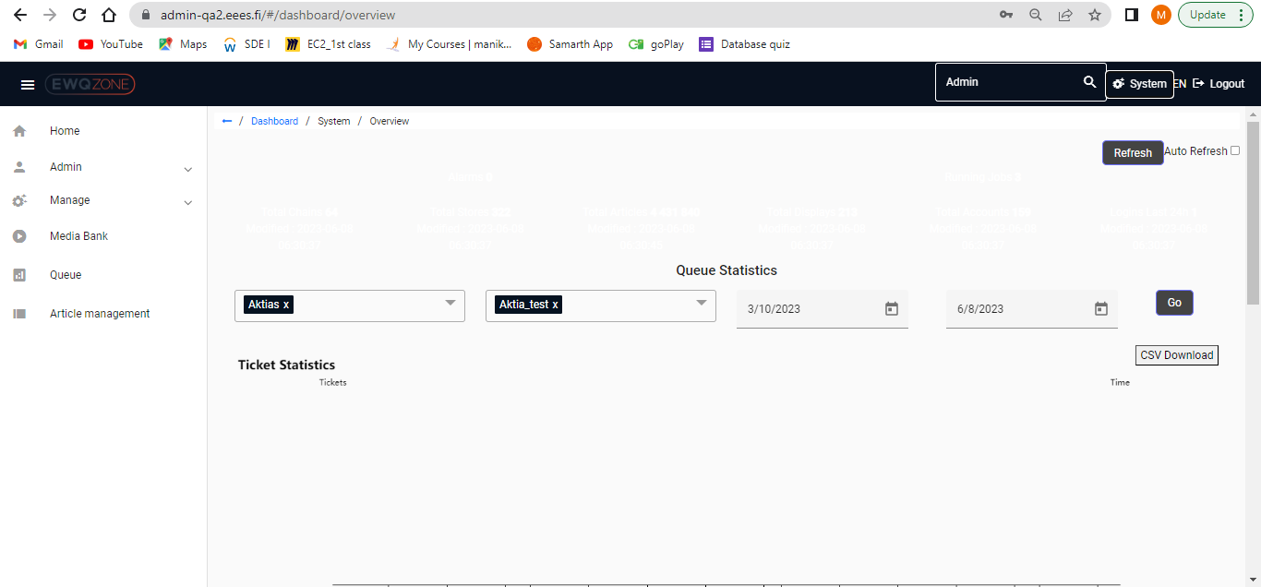

# Origin Tables:

In Access object Page Alignment of Search Functionality and other option should be in proper.

User able to see Distorted UI When user click on origin Tables in dashboard

Alignment of Search function also should be in proper.

Removal of Add new Type option Repeated in UI

Scroll bar is missing.

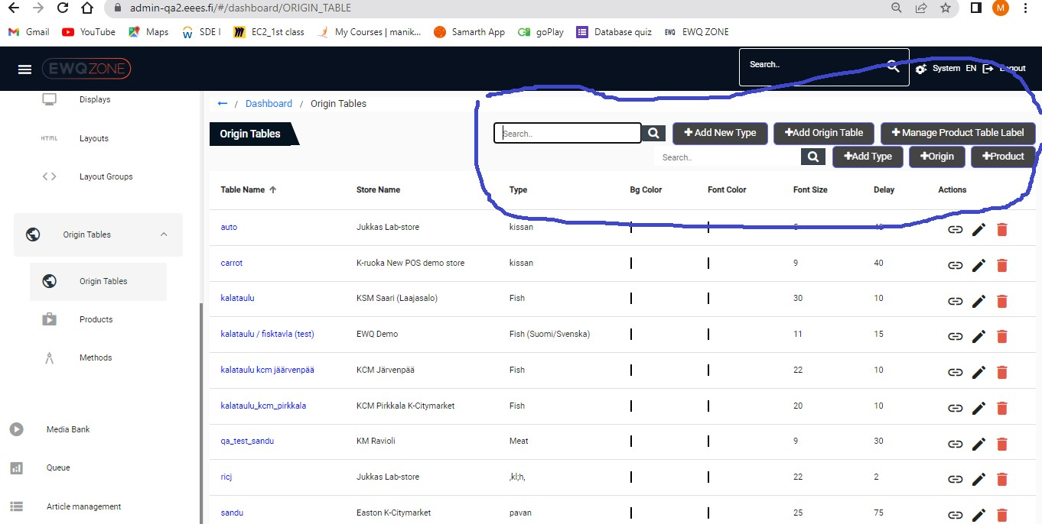

# Products:

Scroll bar is missing to scroll up/down.

Edit Page is not responding:

When User open any product table to edit, the edit product is unresponsive to edit.

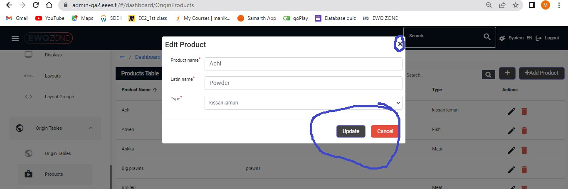

# Methods:

In Access object Page Alignment of Search Functionality and other option should be in proper height.

Scroll Bar is Missing.

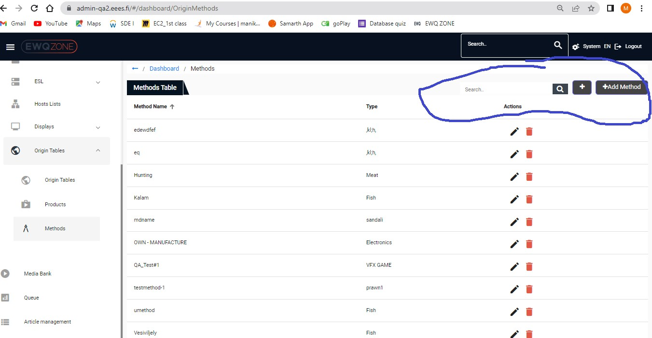

# Media Bank:

User able to see Distorted UI when he trying to open Media Bank page.

Scroll bar is missing to scroll up/down

In Access object Page Alignment of Search Functionality and other option should be in proper height.

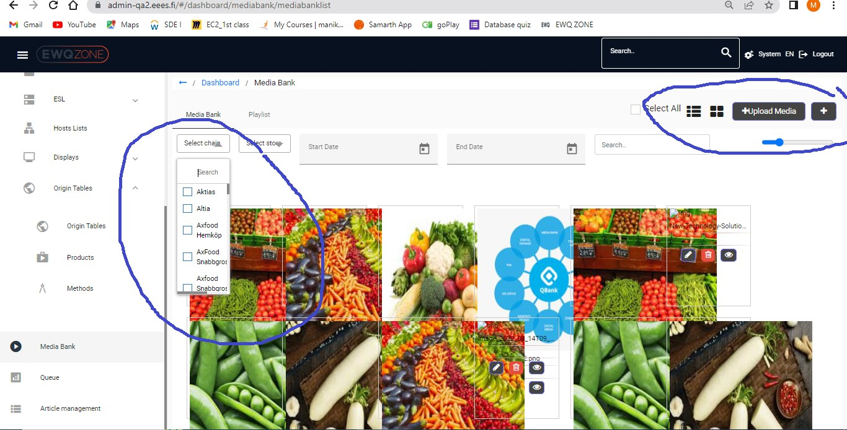

User Not to open / load playlist page in Media bank page.

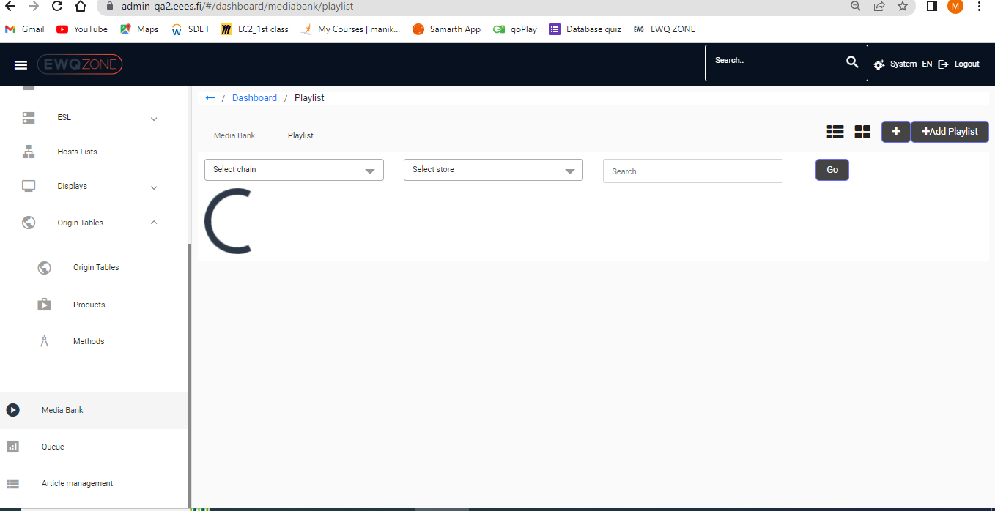

# Article Management:

Page responsive is very low, when trying to open any article/search for an article

User able receive an error message while user able to open article

Scroll bar is Missing to scroll up/down.

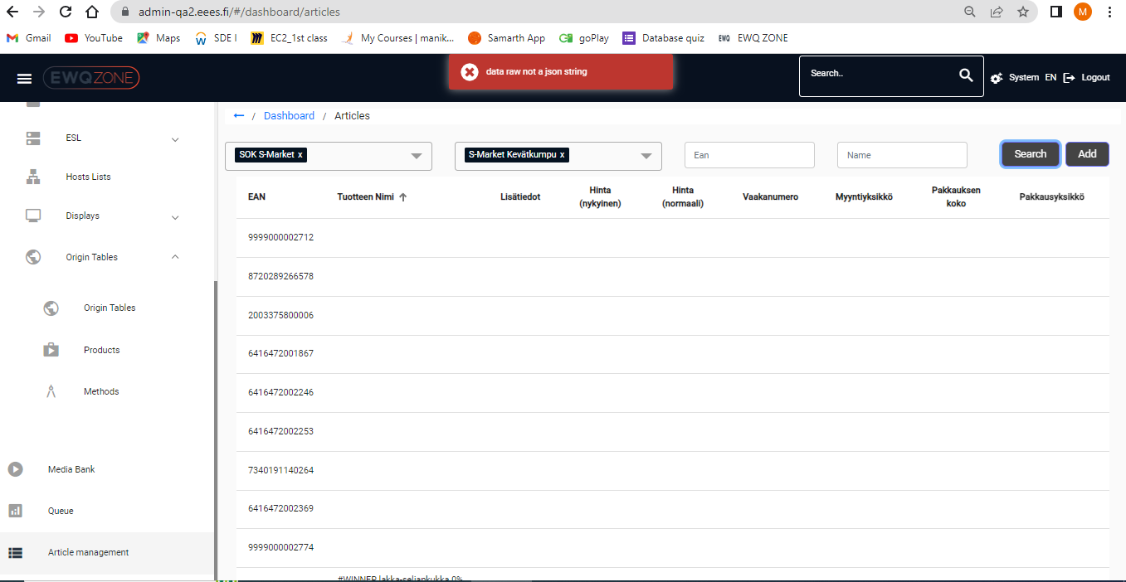

User able to receive a Distorted UI when user click on Add Button in Article management.

